8 weeks Immersion Internship
(June-July or September-October 2015 - 5 persons maximum- Apply early )
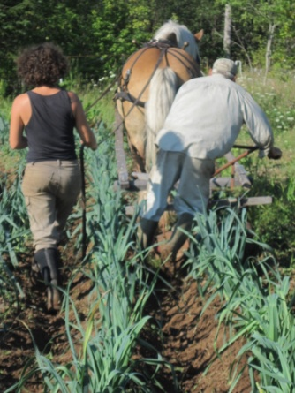
Earn a Permaculture Design Certificate (PDC)
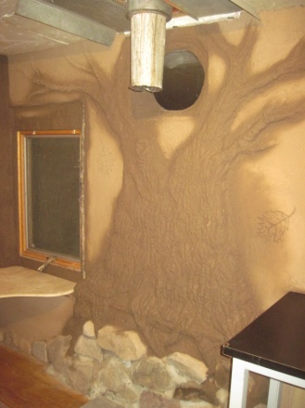
blending hands-on and conceptual learning:
Learn through doing by participating in general farm work (chores, goat milking, hay making, general maintenance...), helping in the kitchen, preserving food, natural building projects, as well as substantial market gardening time

Studies will include project designs and implementation, covering the whole PDC curriculum: 10 hours of class time per week, plus time for reading and study.
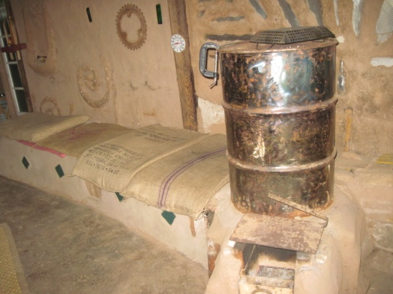

Work trade: no fees, no stipends
Registration and damage deposit fee: $100 – refundable at course completion
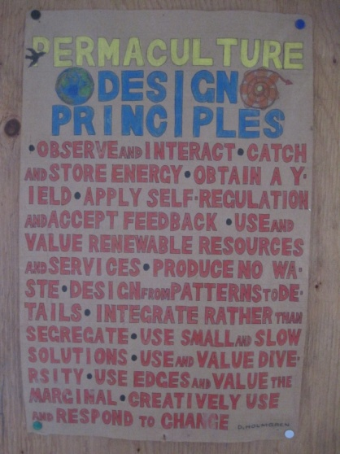
For more information: www.novascotiapermaculture.net
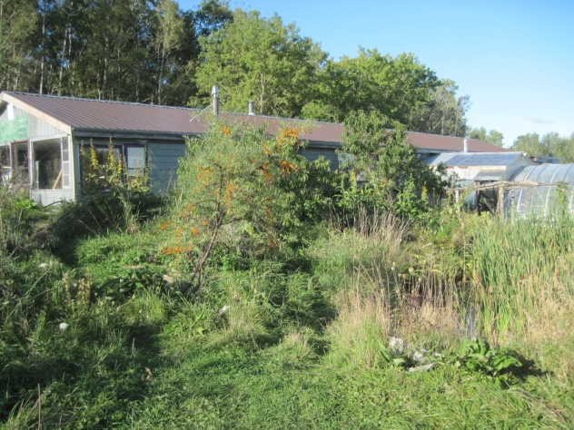
Or contact:
Alex Denicola Mother Oak Permaculture 1217 Belmont Road Newport, NS,B0N 2A0 (902) 792-7041 alexdenicola@hotmail.com

